Michele Byrne Workshop - 2024 SUPPLY LIST

For Value Studies (quick sketches of what you will paint)
4” x 6” Blank Index Cards (you can buy them at Walmart or most anywhere)
Please use whatever you are most comfortable with for these sketches
Use ONE of the following:
• Markers (I use 20, 40, 60 and 80% gray markers)
• Soft lead pencil and erasure
• Or pen

EASEL - If you are bringing your own – OR you can also use the studio easels
- Some type of plein air easel. I’ll be using an https://www.edgeprogear.com (Passport size)
(THIS IS THE ONE I USE FOR TRAVEL)
Or an Open Box M – comes in many sizes. Smaller is better for travel. https://www.openboxm.com/#/
SOLTEK – I use this one when I’m closer to home.

PALETTE
Make sure you have a large CLEAN palette for mixing paint. Glass or plexiglass it best.

CANVAS
1 to 2 small canvases per day - 8”x10” to 12” x 16” (max.)

I use Centurion Linen Panel (acrylic primed),
(IF USING COBRA OILS (or any water mixable oils) DO NOT USE OIL PRIMED LINEN OR CANVAS
Use only Acrylic primed canvas or linen)

Multimedia artboards (best for travel):
https://multimediaartboard.com/products/claessents-109dp-universal-100-belgium-linen-on-multimedia-artboard-5-pack
These panels are lightweight, easy to trim down and mount when you get home.
Use Discount code MBW23

PAINT
I use Cobra Solvent Free Oils as well as traditional Rembrandt oils - feel free to use whatever oils you are most comfortable with. For classes I paint with Cobra Paint
Listed below is the name of the traditional / Cobra paint names are occasionally different, but are basically the same color.
Primary Cyan (Cobra) much cheaper/Cerulean Blue
Ultramarine Blue
Permanent Green Deep / Viridian
Transparent Oxide Red
Madder Lake (Cobra), Permanent Alizarin
Cadmium Red Light (or Permanent Red Light)
Cadmium Orange (or Permanent Orange)
Yellow Ochre
Permanent Yellow deep
Permanent Lemon Yellow
Titanium White
Primary Magenta

I try not to use any medium, which makes me use more paint. For fine lines and details at the end of my painting I sometimes use Cobra Quick Dry Medium or Cobra Glaze.
I also use Cobra Paste occasionally (these mediums you do not need for the class)
Suggested BRUSHES
Flats #2,6,10 (just a few of these are needed – or just bring what you have)
*Watercolor Rigger or liner # 1 (this is important for adding final highlights)
Large 1 1/2” chip brush from Lowes or any larger brush for washes.

PALETTE KNIFE - A trowel Palette Knife for mixing and applying paint (2 inch minimum blade)
MY FAVORITE: 30 Italy RGM Plus – available through DickBlick

https://www.dickblick.com/items/blick-painting-knife-78-x-2-34-painting-style-30-/
VIEWFINDER – PLEASE BRING A VIEWFINDER OF SOME TYPE

One of these Scraper tools:

Barvotti Silicone Shaper tool – 2”

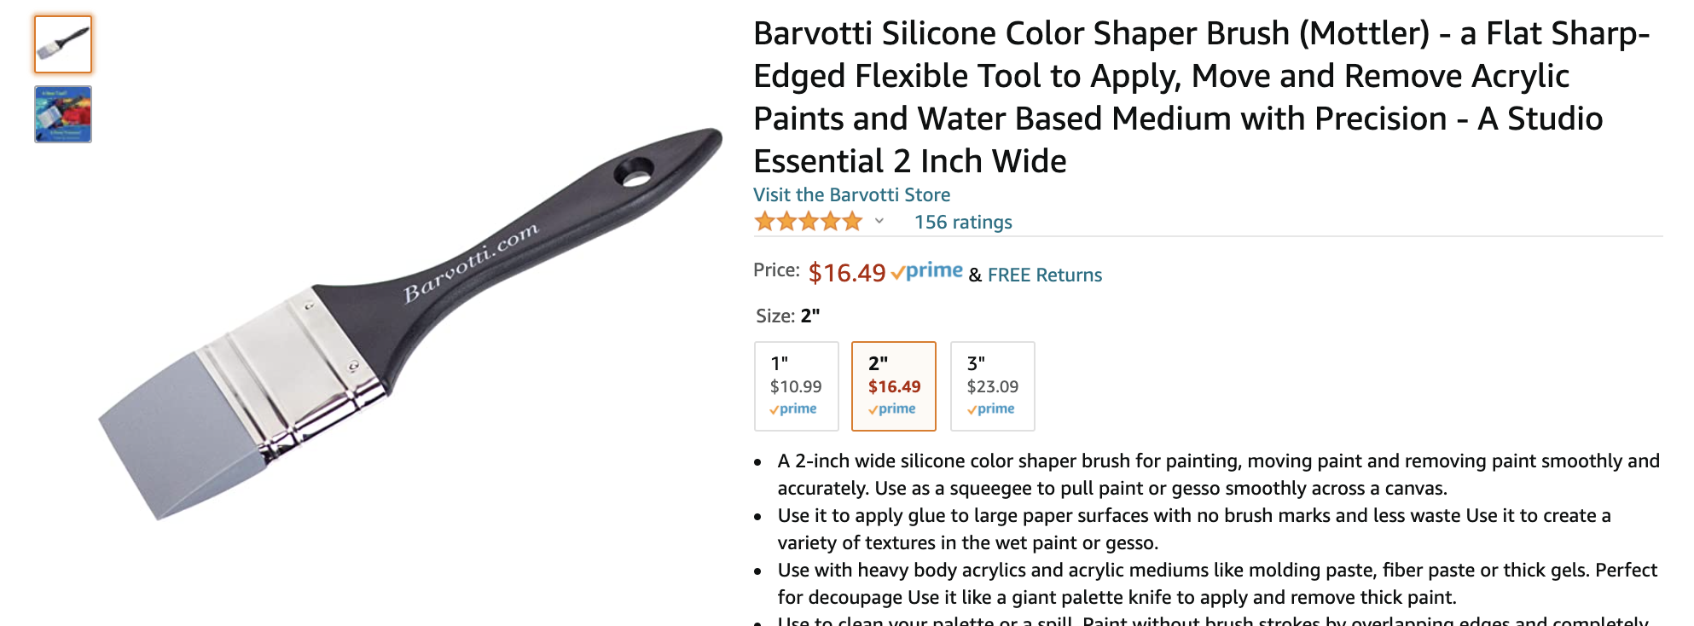

Princeton Wedge – Shape 1 - Catalyst Tool
https://www.dickblick.com/items/03422-1001/

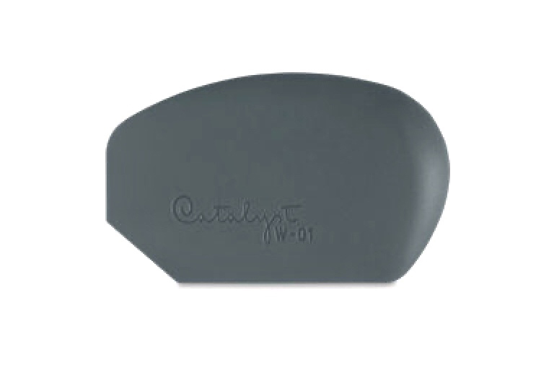
Gloves - I wear gloves when I paint. It allows me to feel free to be a slob and not worry about health hazards.
WET PANEL CARRIER:
To get your paintings home safely. (Pizza boxes work well too)
I use RayMar Wet Panel carriers
https://www.raymarart.com/collections/wet-painting-carriers

